Maths Activities
- ​Find a book in your house. Can you find three items which are longer than the book and three items which are shorter? Order the items from longest to shortest. Measure the items to work out the difference in lengths.
- ​Look at flags from around the world either in books or on the internet​. Can you list the shapes you can see and name the properties of the shapes you find? Do any of the flags have a line of symmetry?
- ​Get a chocolate bar and investigate if it can be split into half, quarters and thirds. You could investigate whether the size of the chocolate bar affects how much they get. Does ½ always look the same?
English Activities
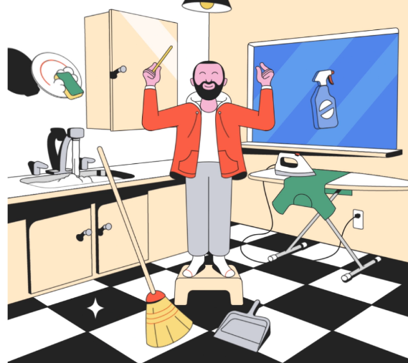
He closed his eyes tightly, waved his magic wand and carefully whispered the magic words. Excitedly, he opened his eyes to see...
- Use the picture to help you finish the story.
- Write the beginning of the story. Think about: where he found a magic wand, how he worked out what it did, what he used it for first.
- Write a diary entry for a day you found a magic wand. Include where you found it, how you worked out it was magic, what you used it for.
Topic Activities
- Look at the work of Giuseppe Arcimboldo. Using different drawing materials, can you create a picture of your own?
- Look at the facts you have found out about Helen Sharman. Is there anything else you would like to know about her or her trip to space? Write down some questions you would like to ask her.
- Design a new spacesuit for Helen Sharman. Why would this be a good spacesuit? How could it be improved?
Science Activities
- Balanced diet: Watch this video about how to have a balanced diet. https://www.bbc.co.uk/bitesize/topics/zv4cwmn/resources/1 Play these games about healthy eating.
http://resources.hwb.wales.gov.uk/VTC/healthy_eating/eng/Introduction/default.htm
- What do we have today? Look in the kitchen to see if you can create an A-Z list of fruit and vegetables - Draw pictures of fruit and vegetables in your house. Label the fruit and vegetables and place in alphabetical order.
- Sorting activity: Collect food from the kitchen and sort into healthy and unhealthy foods.

