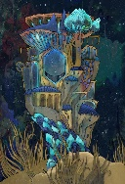

If you have access to the internet- watch ‘Octonauts: plenty of fishes under the sea’ on Youtube.

You could watch ‘The Little Mermaid’.

How many different animals can you spot and name?

Make up your own sea creature or character. What will they look like? Where do they live? Are they good or bad? Can you describe them? Can you think of a story about them?

**The Ocean Activity Ideas**

Can you build the longest trident? You could use empty tissue roles or rolled up newspaper.

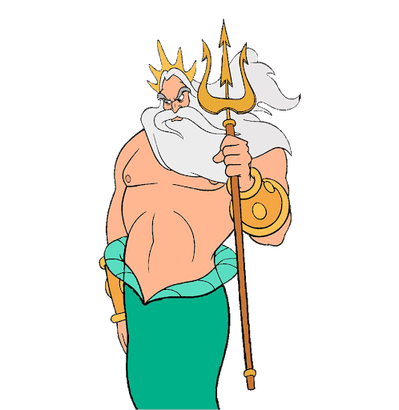

Can you measure your trident?

Paint or draw your favourite sea creature.

Build an underwater kingdom like in ‘The Little Mermaid’. You could use building blocks or even plastic bottles and boxes from the recycling.

Think about different underwater characters. Can you move like they would? Can you walk sideward like a crab? Swim like a mermaid? Be imaginative! 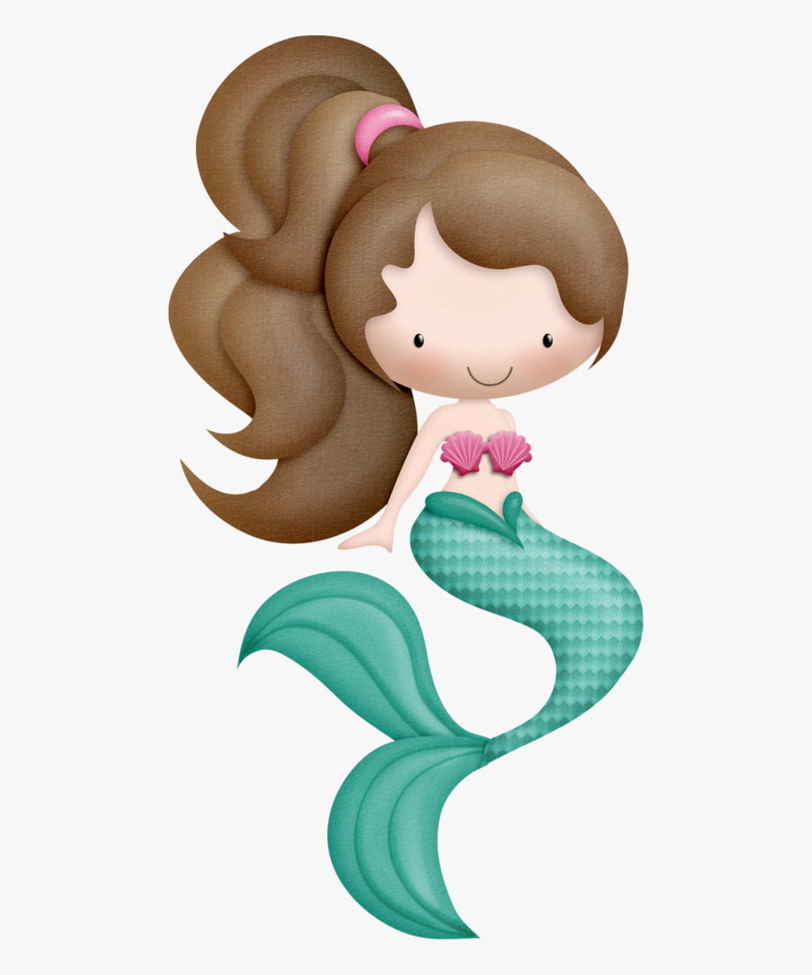

Can you find items in your house that would float in water? Then find items that you think would sink in water. With an adults help test out your predictions in a bowl of water or in the bath.

You could see which of your toys float or sink in your paddling pool.

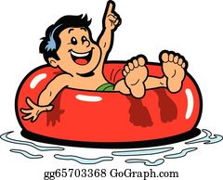

Can you use a range of blue tones to create the ocean? You could use crayons or felt tips or paint.

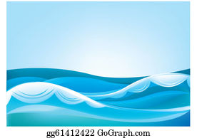

Write a card or letter to your favourite character. What will you say to them? Can you use To and From in your letter?

Get an adult to help you bake some starfish shaped biscuits. Help to measure out the ingredients and mix them all together. Look closely at the changes that occur from when you begin to when they are baked. How many points are there on a starfish? I wonder how many there are altogether? Can you count in 5’s?

