Gosford Park Primary School Weekly Newsletter
‘Your future begins here’ Friday 26th June 2020

Message for parents
Dear Parents/carers

The weather has been beautiful this week. I hope you have enjoyed some time outside.

We have had further bubbles of Year 6 children in school this week and are going to be welcoming back some of our Year 1 children next week. Due to staffing capacity, it is unlikely that we are going to be able to expand this further to anymore year groups as we are also staffing our Key worker provision.

I hope that you all received your new home learning pack this week and your sunflower seed ready for planting. Please send us some photographs as they get growing !

You may have read or heard that the Government are going to be supplying Free School Meal children with a Summer Food Voucher. This will be one voucher that will be posted to you in the same way as the other vouchers. It will not arrive with you until the first week of the Summer holidays at the earliest. I will provide you with more information about this as additional guidance arrives.

With best wishes
Mrs Baddeley

Message for our children
I hope you have managed to enjoy the sunshine this week and have remembered to drink lots of water and put your sun cream and sunhat on.

You should have received your sunflower in the post. Make sure that you are watering it well so that it flourishes.

I’m still missing you ll lots and can’t wait to see you all in school again

Mrs Baddeley

Work Packs and Reports

The next work pack you receive through the post will be focused on Well Being. The teachers of each year group have put together some Well being activities for your child to do as they wish. They are really lovely packs and I know the children will love some of the activities. This report will also contain your child’s school report. Please bear in mind that school reports are written based on your child’s achievements prior to lockdown. There will be an opportunity for you to discuss your child’s report but this will now be next academic year.
Next Year…
We are busy planning for next academic year. Part of this, is the organisation of classes. You will receive in the post a letter informing you of who your child’s teacher will be next year. I want to reassure you that although there has not been an opportunity for the transition work and day that we would usually have, we will, depending on how we are expected to organise school be providing transition at the beginning of next year in September.
Your child will also receive a letter from their new teacher and a Summer Challenge linked to their new topic.

Please keep safe online everyone !
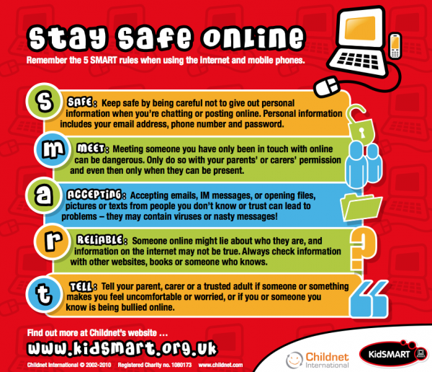

Make a Mindfulness Glitter Jar
