Date:_____________________ Name:____________________________
Match the ai pictures and words.
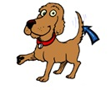 | 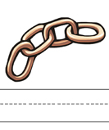 | 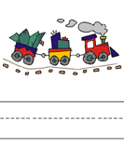
_ _ _ _ | _ _ _ _ _ | _ _ _ _ _
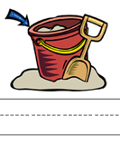 | 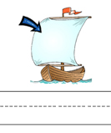 | 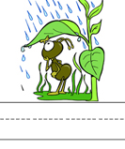
_ _ _ _ | _ _ _ _ | _ _ _ _
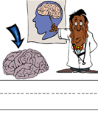 | 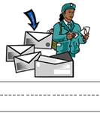
_ _ _ _ _ | _ _ _ _

Brain mail rain tail chain pail sail train

AI Word Search
Write the words from the word bank under the correct pictures then find them in the grid below.

Word Bank
brain | mail | rain | tail
chain | pail | sail | train
