Match the ar words with their pictures:

|  |  |  |
| --- | --- | --- |
| barn | http://4.bp.blogspot.com/_ue2_vDGeEV8/TDTTZxnyQTI/AAAAAAAABQc/DSEQxeYgwFs/s1600/vectorclipart_06.gif | http://www.känerkarnevalclub.de/Clipart_Casino_card_hand_hearts_266.jpg |
| _ _ _ _ | _ _ _ | _ _ _ _ _ |
| http://www.clipartheaven.com/clipart/occasions/birthdays/party.gif | http://www.clker.com/cliparts/f/9/8/1/1216181106356570529jean_victor_balin_icon_star.svg.med.png | http://lindleypark.asheboro.k12.nc.us/Uploads/images/Clipart/clip_art_art_8.jpg |
| _ _ _ _ _ | _ _ _ _ | _ _ _ |
| Sharp kitchen knife | http://bestclipartblog.com/clipart-pics/farmer-clip-art-4.gif | http://www.clker.com/cliparts/a/c/c/b/11971056661159228234DTRave_Glass_Jar.svg.hi.png |
| _ _ _ _ _ | _ _ _ _ _ _ | _ _ _ |

Star jar sharp party cards car barn art farmer

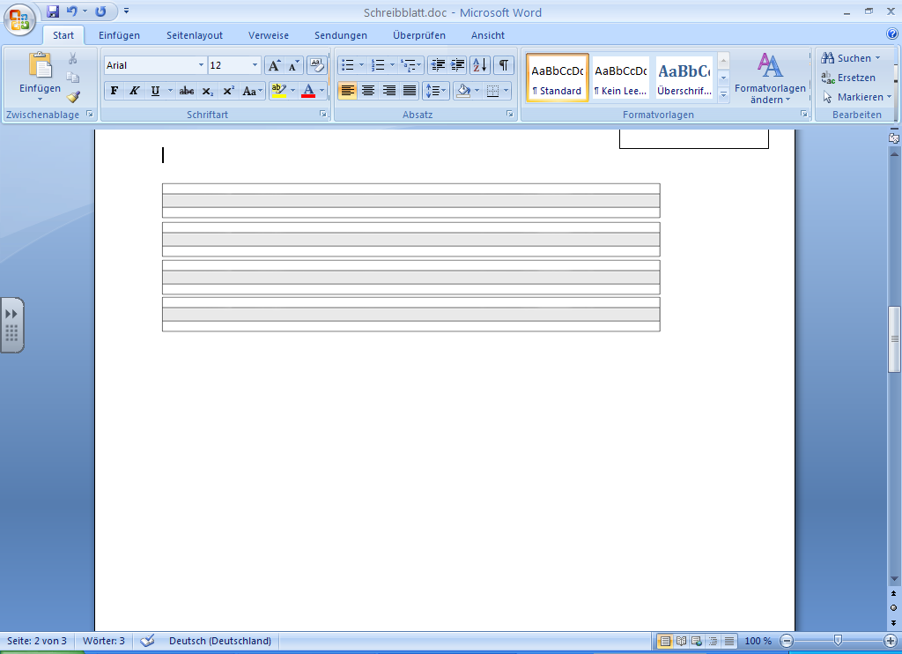

AR Word Search

|  |  |  |  |
| --- | --- | --- | --- |
| Write the words from the word bank under the correct pictures and then find them in the grid below.  **Word Bank** | | | |
| arm | car | dark | farm |
| jar | park | shark | star |
|  | | | |
| farm | arm | car | shark |
| dark | park | jar | star |
| ARsearch | | | |