Match the ow words with their pictures:

|  |  |  |
| --- | --- | --- |
| http://free.clipartof.com/49-Free-Cartoon-Cow-Clip-Art.jpg | http://www.clker.com/cliparts/9/2/f/f/1197148439997296199liftarn_Crown_of_Saint_Edward.svg.med.png | http://bestclipartblog.com/clipart-pics/clown-clip-art-5.jpg |
| _ _ _ | _ _ _ _ _ | _ _ _ _ _ |
| http://www.clker.com/cliparts/1/6/5/3/1206570668474050631nicubunu_RPG_map_symbols_Village.svg.med.png | http://dir.coolclips.com/clipart/150/vgjm/tf05309/CoolClips_vc062079.jpg | http://im.glogster.com/media/15/39/33/92/39339293.jpg |
| _ _ _ _ | _ _ _ _ _ | _ _ _ _ |
| http://www.clker.com/cliparts/9/a/e/e/12154415151126295659lemmling_Cartoon_owl.svg.med.png | http://www.clker.com/cliparts/Y/t/F/2/t/o/ink-splash-with-drops-brown-md.png | orange smiley frown |
| _ _ _ | _ _ _ _ _ | _ _ _ _ _ |

Owl frown crown town towel clown down brown cow

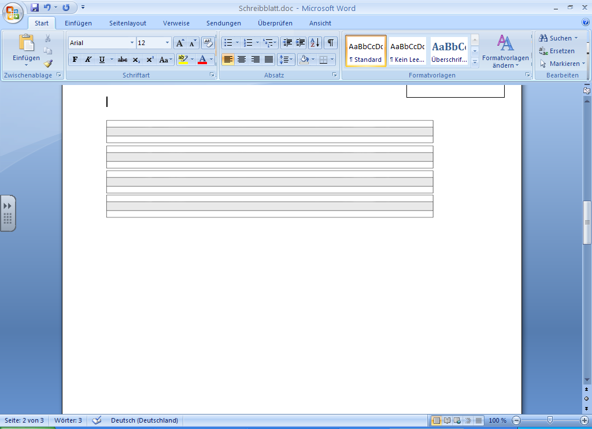

OW as in Cow Word Search

|  |  |  |  |
| --- | --- | --- | --- |
| Write the words from the word bank under the correct pictures then find them in the grid below.  **Word Bank** | | | |
| brown | clown | cow | crown |
| down | owl | towel | town |
|  | | | |
| clown | crown | towl | cow |
| town | brown | down | owl |
| OW2search | | | |