Can you match the qu words with the pictures?

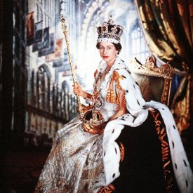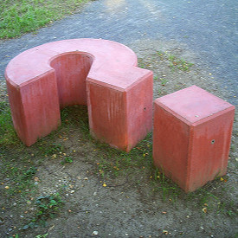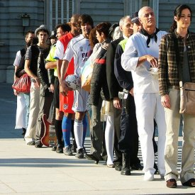

\_ \_ \_ \_ \_ \_ \_ \_ \_ \_ \_ \_ \_ \_ \_ \_ \_ \_

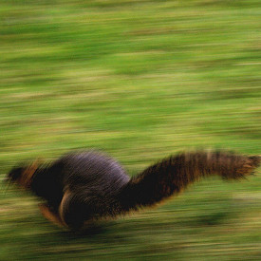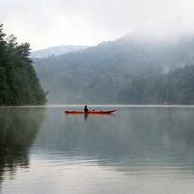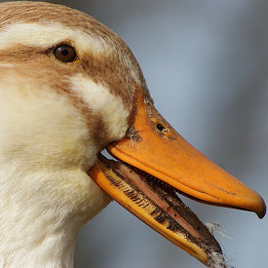

\_ \_ \_ \_ \_ \_ \_ \_ \_ \_ \_ \_ \_ \_ \_

quack question quiet queue queen quick

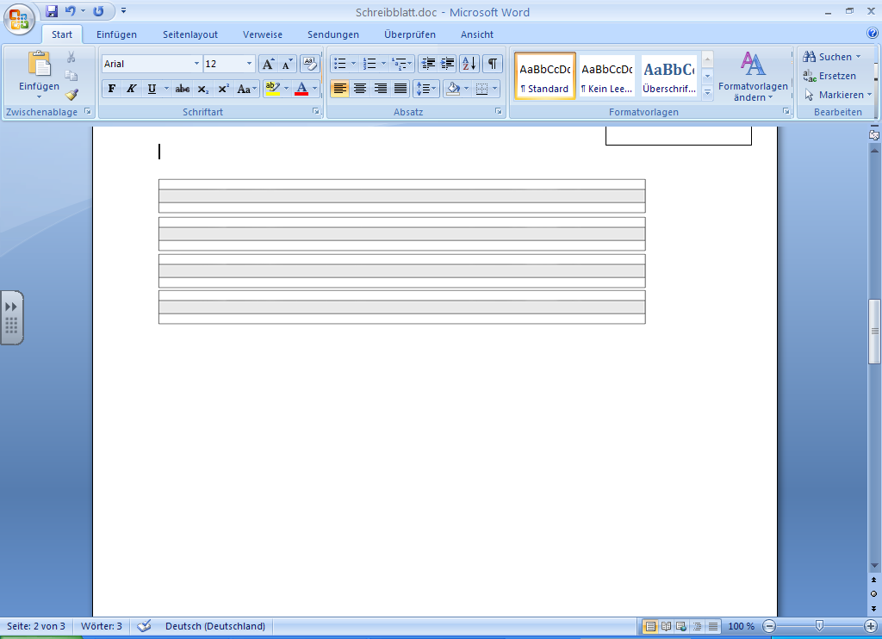





|  |  |  |  |
| --- | --- | --- | --- |
| \_ \_og | [istockphoto_861721_frog_cartoon](http://images.google.co.uk/imgres?imgurl=http://www1.istockphoto.com/file_thumbview_approve/861721/2/istockphoto_861721_frog_cartoon.jpg&imgrefurl=http://www.istockphoto.com/imageindex/861/7/861721/Frog_Cartoon.html&h=270&w=270&sz=63&hl=en&start=5&tbnid=VW_C7vr0HwNxdM:&tbnh=113&tbnw=113&prev=/images?q=frog+clipart&svnum=10&hl=en&lr=) | \_ \_ag | [flag_clipart](http://images.google.co.uk/imgres?imgurl=http://www.imajlar.com/free_clipart/flag_clipart/flag_clipart.gif&imgrefurl=http://www.free-clipart-pictures.net/flag_clipart.html&h=200&w=150&sz=5&hl=en&start=1&tbnid=phOzF7oPCrWmvM:&tbnh=104&tbnw=78&prev=/images?q=flag+clipart&svnum=10&hl=en&lr=&sa=X) |
| \_ \_um | [music_clipart_drum](http://images.google.co.uk/imgres?imgurl=http://www.imajlar.com/free_clipart/music_clipart/music_clipart_drum.gif&imgrefurl=http://www.free-clipart-pictures.net/music_clipart.html&h=170&w=200&sz=8&hl=en&start=3&tbnid=TIAjwXRZXD9EJM:&tbnh=88&tbnw=104&prev=/images?q=drum+clipart&svnum=10&hl=en&lr=) | \_ \_ip | [skip1](http://images.google.co.uk/imgres?imgurl=http://www.saskschools.ca/~gregory/gym/clipart/skip1.gif&imgrefurl=http://www.saskschools.ca/~gregory/gym/skiptips.html&h=354&w=274&sz=6&hl=en&start=2&tbnid=_4dSbgC0ihMkTM:&tbnh=121&tbnw=94&prev=/images?q=skip+clipart&svnum=10&hl=en&lr=) |
| \_ \_ab | [crab](http://images.google.co.uk/imgres?imgurl=http://www.youthonline.ca/clipart/summer/crab.gif&imgrefurl=http://www.youthonline.ca/clipart/summer/more.shtml&h=175&w=215&sz=16&hl=en&start=2&tbnid=8VWqTXZO0Kj-_M:&tbnh=86&tbnw=106&prev=/images?q=crab+clipart&svnum=10&hl=en&lr=) | \_ \_ock | Clock00 |
| \_ \_im | new14 | \_ \_ess | object_clipart_dress |
| \_ \_ush | [Brush_2](http://images.google.co.uk/imgres?imgurl=http://www1.free-clipart.net/gallery/clipart/Household/Cleaning/Brush_2.jpg&imgrefurl=http://www1.free-clipart.net/cgi-bin/clipart/directory.cgi?direct=clipart/Household/Cleaning&h=243&w=272&sz=11&hl=en&start=3&tbnid=o2eXQ_WgnfdfcM:&tbnh=101&tbnw=113&prev=/images?q=brush+clipart&svnum=10&hl=en&lr=) | \_ \_ing | swing |
| \_ \_amp | Queenie | te\_ \_ | [Tent](http://images.google.co.uk/imgres?imgurl=http://s2.insanescouter.com/t276/art/Activities/Camping/Tent.bmp&imgrefurl=http://monk201.tripod.com/id4.html&h=289&w=464&sz=132&hl=en&start=13&tbnid=KvR55JcrfGG7WM:&tbnh=80&tbnw=128&prev=/images?q=tent+clipart&svnum=10&hl=en&lr=) |
| ha\_ \_ | [hand](http://images.google.co.uk/imgres?imgurl=http://media.nasaexplores.com/lessons/02-079/images/hand.gif&imgrefurl=http://www.nasaexplores.com/show_58_student_st.php?id=030109140713&h=183&w=170&sz=2&hl=en&start=2&tbnid=xQ-u5Pimf3nvNM:&tbnh=102&tbnw=95&prev=/images?q=hand+clipart&svnum=10&hl=en&lr=) | sa\_ \_ | istockphoto_406463_beach_shell |
| mi\_ \_ | [milk](http://images.google.co.uk/imgres?imgurl=http://casls.uoregon.edu/clipart_files/Food%20&%20Eating/Dairy,%20eggs,%20meat,%20fish/milk.gif&imgrefurl=http://casls.uoregon.edu/FoodEating.php&h=198&w=181&sz=3&hl=en&start=3&tbnid=ZbXVjEKx-QUIjM:&tbnh=104&tbnw=95&prev=/images?q=milk+clipart&svnum=10&hl=en&lr=) | pi\_ \_ | http://images2.fanpop.com/images/photos/4200000/Pink-pink-color-4286512-2560-1920.jpg |