**Sh words: can you match the words with the pictures?**

|  |  |  |
| --- | --- | --- |
|  | http://www.clipartpal.com/_thumbs/pd/education/paper_sheet.png |  |
| _ _ _ _ _ | _ _ _ _ _ | _ _ _ _ _ |
|  |  |  |
| _ _ _ _ _ | _ _ _ _ _ _ _ | _ _ _ _ _ _ |
|  | https://lh3.googleusercontent.com/-abzo-u82NYw/Tm2LeDNxbBI/AAAAAAAALcM/9-sUInNS1BM/s450/1075284-Clipart-School-Boys-Holding-Tall-And-Short-Flash-Cards-Royalty-Free-Vector-Illustration.jpg | http://bestclipartblog.com/clipart-pics/sheep-clip-art-5.jpg |
| _ _ _ _ | _ _ _ _ _ | _ _ _ _ _ |

Sheep shadow shower shirt shell shark sheet share short

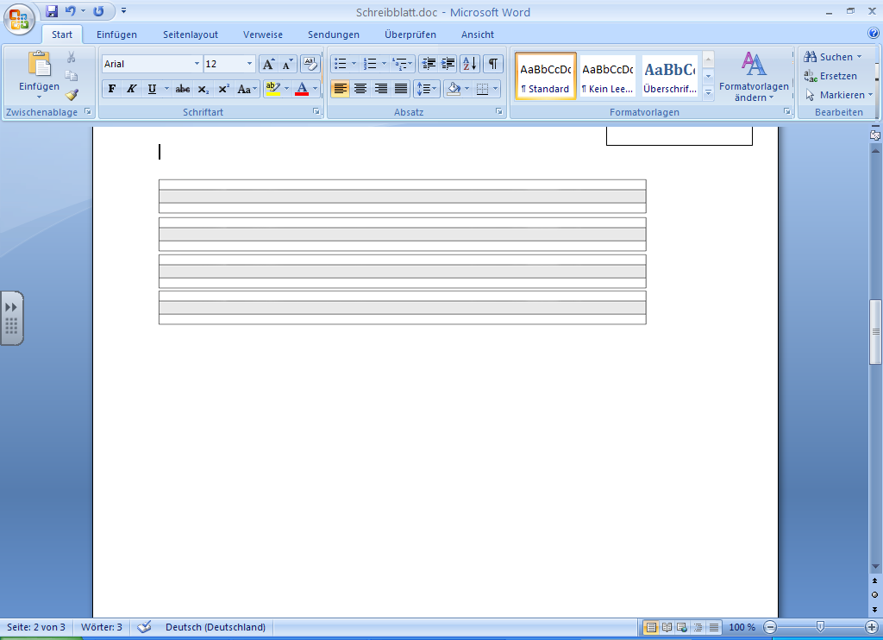

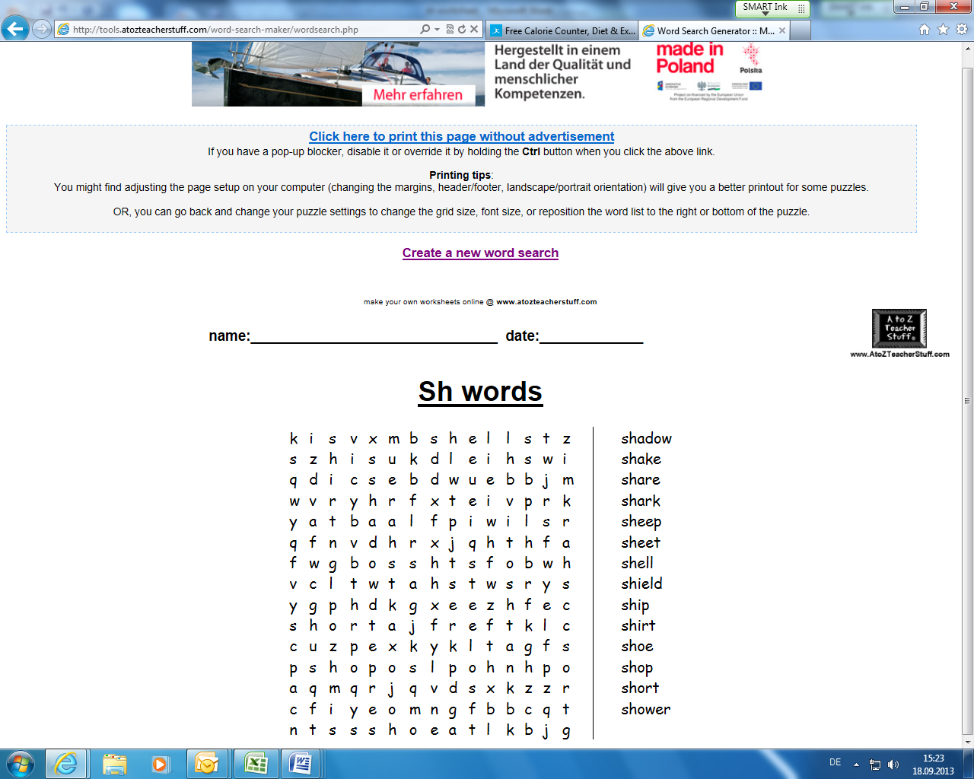

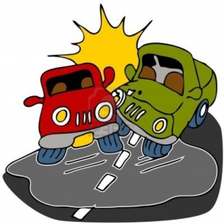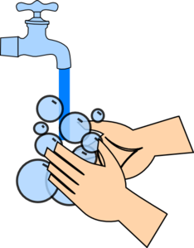

O O O O O

O O O O O

wish flash fish wash crash