WALT: make a chemical reaction

Volcano Experiment

When certain solids are mixed with fluids, this causes a chemical reaction. Today we learnt this through the volcano experiment.

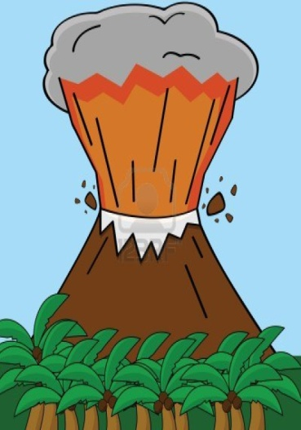
In order for us to carry out this experiment we used the following items:

- Plastic bottle
- Liquid soap
- Bicarbonate of soda
- Carbonated water
- Food colouring

Steps to creating the volcano and the chemical reaction.

water soda chemical reaction
(Please use these words to help you to fill out the blank spaces)

First of all we mixed the carbonated _______, soap and food colouring in a plastic bottle.
Next we added bicarbonate of ______ into the bottle.
When all the ingredients were added, a _________ reaction took place.
This chemical reaction caused the solution to fizz and cause a volcano like _________.

