W/C 15.06.2020: Learning Project - Space
Hi Year Y4. Here is this week’s learning project. Hope you enjoy finding out about space. Don’t forget to post your work on our school Twitter page so we can see what you have been doing.
Weekly Reading Tasks | Weekly Spelling Tasks
Monday- Encourage your child to recreate space and read a story e.g. under dark bed sheets with a torch or even in the garden under the stars (with supervision). | Monday-Task your child with creating their very own space themed word bank e.g orbit, solar, comet. They can refer to this for some of their writing tasks.
Tuesday- Visit Worldbookonline and login using Username: wbsupport and Password: distancelearn. Select eBooks and search for the title’ A Place in Space’. Ask your child to read the book and complete the activities at the back. | Tuesday- Practise spelling these words: division, invasion, confusion, decision, collision, television. Ask your child to list synonyms for each word (words with the same meaning).
Wednesday- Read chapter 1 of Survival in Space: The Apollo 13 Mission together. Ask your child to note down unfamiliar words and explore these together. | Wednesday- Learn to spell the names of all the planets in our solar system. Put them in alphabetical order and then order of size.
Thursday- Encourage your child to explore the surface of Mars on the Curiosity Rover here. What did they notice? What was most surprising? | Thursday- Flash writing. Choose 5 Common Exception words and go into a darkened room with a torch and write them in the air with the torch light.
Friday- Task your child with creating their own Book Bingo. See here for inspiration.Can they complete the game over the next week? | Friday- Using the word bank from Wednesday, ask your child to create their very own space-themed word search. A family member could complete it.
Weekly Writing Tasks | Weekly Maths Tasks- Area and Perimeter
Monday- Visit the Literacy Shed for this wonderful resource on Broken: Rock, Paper, Scissors. Or your child can write a response to this: If I met an alien, I would… Your child could record their responses in a list to form a list poem and then perform it. | Monday- Give your child an A4 piece of paper and mark out a rectangle 12cm by 24cm. They are designing a vegetable patch and need to include the following areas: A carrot zone with a perimeter of 32cm, a pea zone with an area of 12cm squared, a strawberry zone with an area of 20cm squared and a perimeter of 18cm.
Tuesday- Ask your child to write a diary entry about what it would be like on a Space Station.What do they miss about life on Earth? More inspiration here. | Tuesday- Following on from yesterday, your child can design 3 more zones of their choice but there must be a difference of at least 2cm between each of the areas.
Wednesday- Encourage your child to create a travel brochure for a planet of their choice or to promote space tourism in general. Make sure they include information about travel times, accomodation, food and things to do and see. If you have access to a PC, this could be done on Word or Google Docs. | Wednesday- ‘Conquer the Area’. You will need: square paper or draw a square grid, 2 different colour pencils and 2 dice. Roll the dice and multiply the two numbers together. Whoever rolled the dice draws this area on the square grid with their pencil. Fill up the whole page - whoever has taken up the most space wins.
Thursday- Ask your child to write a story about a character who went into space for the day. Ask them to think about which time openers (e.g. Later that day,) they could use and how they could build suspense to engage the reader. | Thursday (other)- Practise counting in multiples of 50 and 100 forwards and backwards. Record these sequences on paper.
Friday- Create an information poster about Neill Armstrong. Remind your child to use labels and captions. What diagrams could they include? | Friday (other) - Visit this website for more space-themed activities or play this Space Rocks game.

Learning Project - to be done throughout the week
The project this week aims to provide opportunities for your child to learn more about space. Learning may focus on our Solar System, the Sun and the Moon. It could look at life in outer space from the view of an astronaut and travelling through space.

- Our Solar System- Encourage your child to think about what they already know about space and create a mind map. Can they name the planets in our solar system? Can they remember them in order or create their own mnemonic to help them? Ask your child to research the characteristics of the planets e.g What is it made of? What size is it? How close to the Sun is it? Temperature? Can they create a fact file, PowerPoint or Google Slide presentation on a planet of their choice? These facts about Mars or these facts about space may be a good starting point.

- Blast off!- Ask your child to design a new spacesuit suitable for an astronaut. They will need to consider which materials would be most suitable, comfort for the astronauts and the temperature in space. Encourage them to design a logo for the spacesuit too. Perhaps they could make this using materials from around the home? Share your designs at #TheLearningProjects.

- Astronaut Aerobics- Astronauts have to be fit and agile for their missions to space. Ask your child to design an obstacle course in your garden or home space and put your agility to the test! Can you find your pulse and count your heart rate before and after exercising? Recommendation at least 2 hours of exercise a week.

- Out of this World- Ask your child if space travel was made more accessible and they could go on holiday to space, would they like to be the first space tourist? Can they think of arguments for and against being the first space tourist? Is it unethical for millionaires to spend their money on space tourism or should they spend all their money on reducing poverty? Ask them to prepare a speech about this discussion point.

- One Giant Leap for Mankind - Ask your child to find out about Neil Armstrong. Who was he and what challenges did he have to overcome during his life? Can they write a biography or create a piece of drama about Neil Armstrong’s life and achievements?
Coronavirus and Wellbeing- Looking Forward
The change that Covid-19 has caused to our lives has been difficult and has provided countless challenges. For many children, the uncertainty and disruption to everyday life has caused worry and anxiety. These tasks are designed to help children process the current situation, begin to make sense of it and plan for returning to a different normal.

Think
- Reading or being read to offers hope and positivity. The Book of Hopes aims to comfort and encourage children during these unusual times.
Talk
- Talk to your child about what they have found most challenging over the last few weeks and what has helped them most during these difficult times. Which of these things are they or you as a family going to continue to do as things return to normality? E.g continue with daily walks or play more family board games. Write a pledge as a family, recording all of things that you will continue in the future.
Do
- Task your child with writing a letter to their future self. Ask them to include advice about things that have helped them to cope and feel optimistic over the last few weeks. When/if your child feels anxious or worried, ask them to read the letter to help them through these days.
Visit
- If your child is struggling to adapt to the ‘new normal’, Mind Ed for Families offers safe and reliable advice on supporting children’s mental health and wellbeing.
STEM Learning Opportunities #sciencefromhome
Mission X – Jump Training
- Stronger bones help astronauts stay safer while performing all of their assigned tasks – whether in a space vehicle, on the moon, Mars, or once back on Earth.
- Your bones become stronger when you do exercises that support your weight, such as running or jumping. Train like an astronaut by skipping on the spot for 60 seconds without stopping. Rest for 30 seconds. Repeat three times. Vary and extend by adding jumping jacks, travelling forward and by increasing length of time. You can find out more here.
- Sign up and access all of the Mission X resources here.
Staying Safe Online
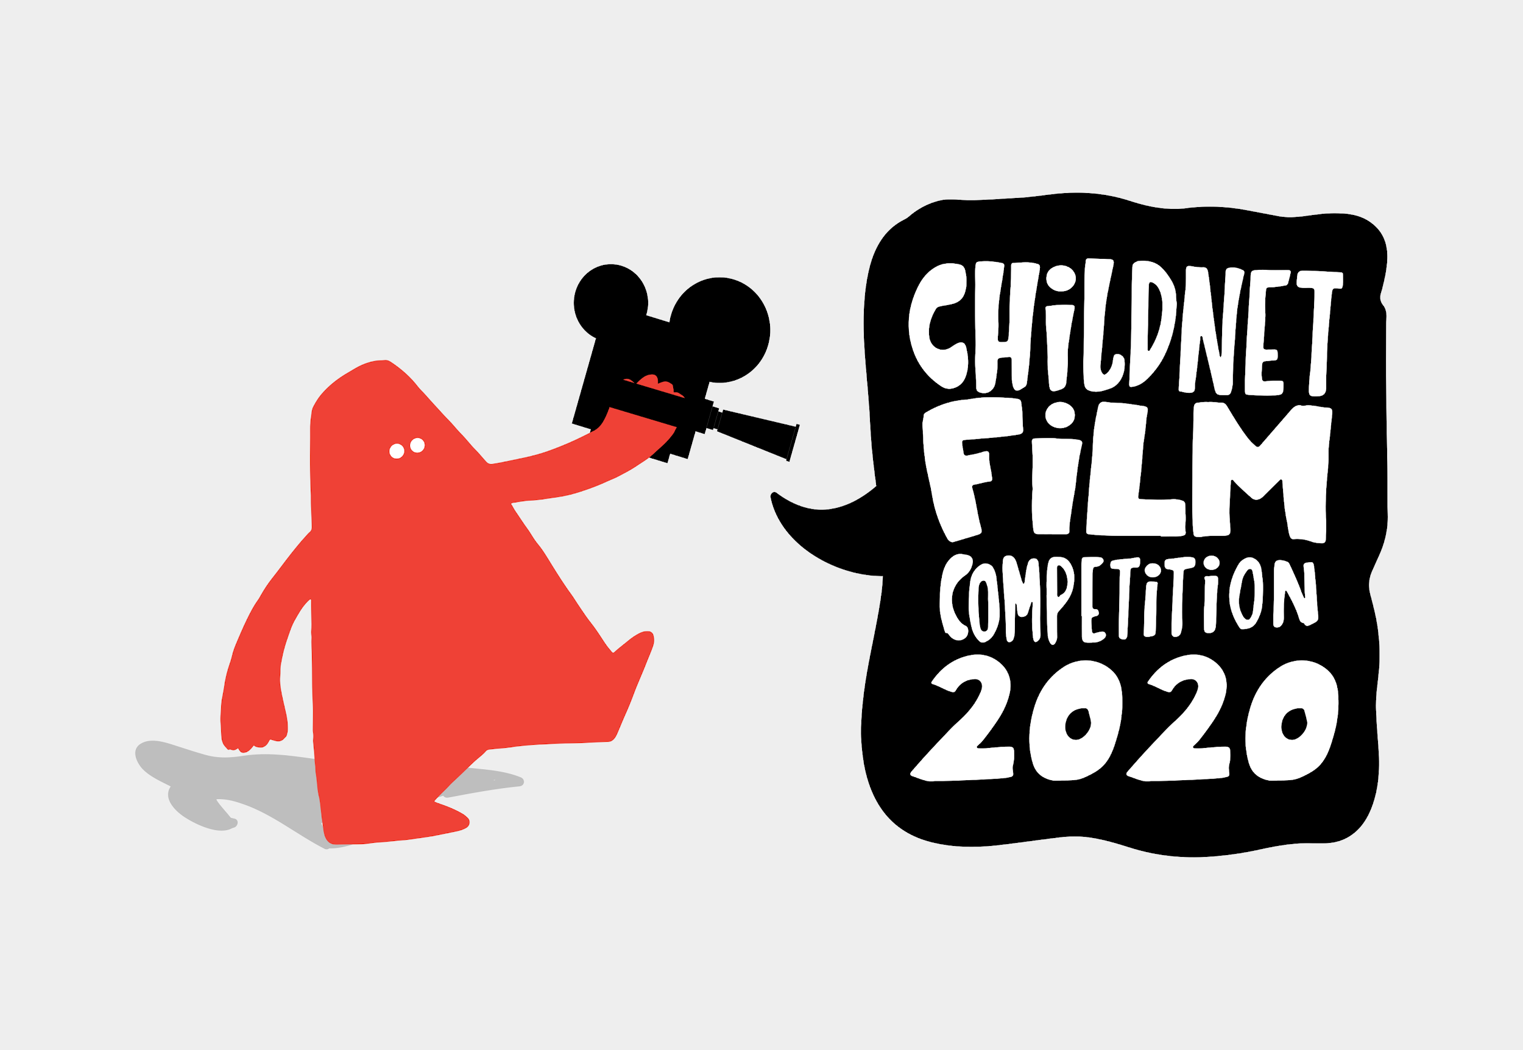
Staying safe online is called 'digital literacy' and this means having the skills and knowledge to use the internet safely and responsibly. It is where someone can manage online content and communication, spot possible risks, and find ways to protect themselves from these risks. You can find out more by visiting Childnet.

Your child could have a go at entering The Childnet Film Competition which invites young people aged 7-18 to create a 2 minute online safety film to inspire their peers to create a safe, supportive and fun online world around the theme ‘We want an internet where we’re free to…’ The entries that make into the final shortlist will be judged by a prestigious panel made up of representatives from BAFTA, the BBC, the British Board of Film Classification, the BFI, Disney and the Motion Picture Association. The young people who create winning films and storyboards will receive great filmmaking and creative prizes for their school or youth group. Whether used at school or as a home learning project, the competition is a great way of exploring important internet safety messages with young people of all ages. Find out more here.
Additional learning resources parents may wish to engage with
- BBC Bitesize - Lots of videos and learning opportunities for all subjects.
- Classroom Secrets Learning Packs - Reading, writing and maths activities for different ages.
- Twinkl - Click on the link and sign up using your email address and creating a password. Use the offer code UKTWINKLHELPS.
- White Rose Maths online maths lessons. Watch a lesson video and complete the worksheet (can be downloaded and completed digitally).
- IXL online. Click here for Year 4. There are interactive games to play and guides for parents.
- Mastery Mathematics Learning Packs. Take a look at the mastery mathematics home learning packs with a range of different activities and lessons.
- Y4 Talk for writing Home school booklets are an excellent resource to support your child’s speaking and listening, reading and writing skills.
The Learning Projects are based on the National Curriculum expectations for the key stage which your child is in. It may be that your child finds the tasks set within the Learning Project for their year group too simple. If this is the case, then we suggest that your child accesses the Learning Projects which are set for the key stage above. Equally, if the projects are too challenging, then we advise that your child accesses the projects for the key stage below.
If your child requires more of a challenge, or you believe that there are some gaps in their learning then Century Tech is a fantastic resource that is currently free for home learning. The app is designed to address gaps and misconceptions, provide challenge and enables children to retain new knowledge. It uses artificial intelligence to tailor the learning to your child’s needs. Sign up here.
#TheLearningProjects
in collaboration with
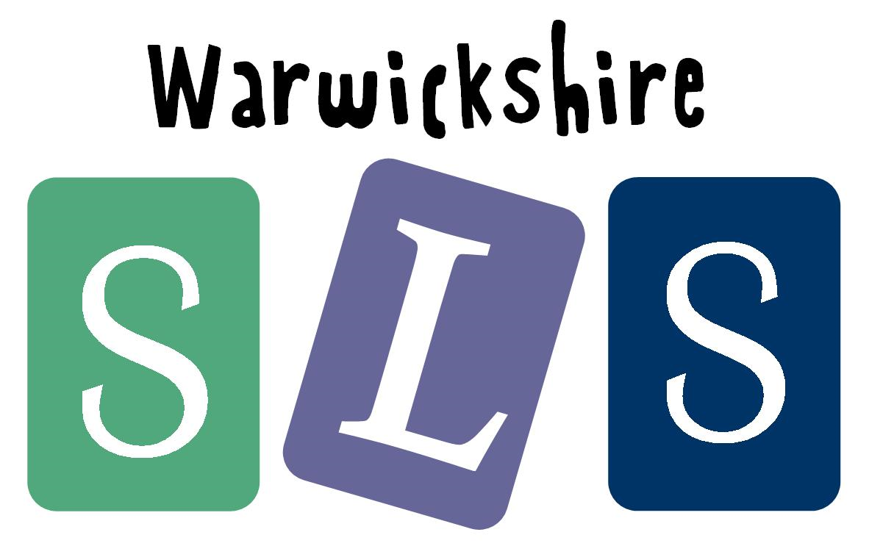
www.robinhoodMAT.co.uk

